**CPE 133 Final Project Proposal**

Prof. John Callenes-Sloan

Luis Gomez, Hayden Rinn, Matt Hoertig

PID Controller

**Summary**: For our final project we will create a PID controller using the BASYS board. If possible, we will also try to implement our PID controller for the purpose of constructing a ball-balancing robot. We chose this project because it presents an opportunity to learn about robotics, PID controllers, and the implementation of PID control using “low-level” digital design. A PID controller implemented using “low-level” digital design tools such as Verilog could potentially operate faster than those designed using higher-level hardware languages. Inspiration for this project came from an Instructable found [here](https://www.instructables.com/id/Ball-Balancer-and-PID-Fiddler/).

**System Architecture:** The following diagram displays the overview of the project. The resulting feedback from a sensor mounted on the ball-balancing apparatus will provide information on the position of the ball on the balancing rail. The BASYS-Board PID controller (which we will create) will apply a PID algorithm to the input signal and output the appropriate signal to be read by a servo motor which rocks the ball balancing apparatus.

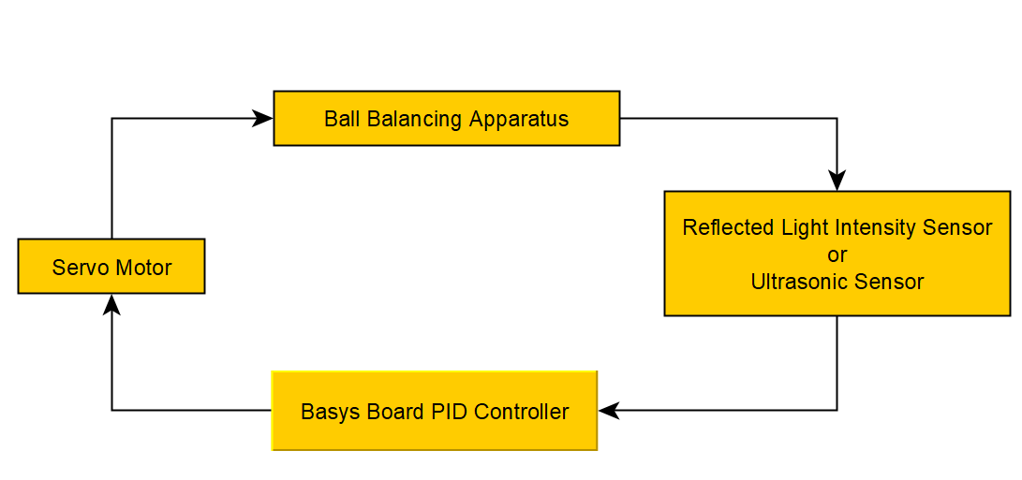

**System Architecture:** As of right now, we suppose the following function blocks will be created:

* Process Variable to Servo module:
* Proportional Term module:
* Integral Term module:
* Derivative Term module:
* Sensor Input to Error Value module:

